**Overview of EMF based Rodin plugin development**

(**Eclipse Feature** *= What we call a Rodin Plugin*

* Eclipse Plug-in)

**Event-B EMF Framework**

*A way to load Rodin’s Event-B models into EMF*

*(ref: EMF4EventB.pdf)*

* Meta-model
  + Extensibility
* Serialisation (via Rodin API)
* Formulas (used by Camille)
* Compare (used by Teamwork)

**Event-B EMF Extensions** (used by iUML-B)

*Support for Extending Event-B EMF models*

*(ref: DiagramExtensionInRodin.pdf)*

* Meta-model
* Navigator
  + Refinement participants – Clone model, Generated copier
* Persistence
  + Serialised Extensions – for models not visible to Rodin

**Event-B EMF Diagrams** (used by iUML-B)

*Support for Diagrammatic Editors for* *Extensions of Event-B EMF models*

*(ref: DiagramExtensionInRodin.pdf)*

* Meta-model
* Generator (alt. QVTO)
* Navigator
  + Open Diagram Action
  + Delete Diagram Handler
  + Action Provider
  + Diagram Provider – Register your diagram editor
  + Refinement Participant – Diagram Copier

**Example: iUML-B Statemachines**

**metamodel**

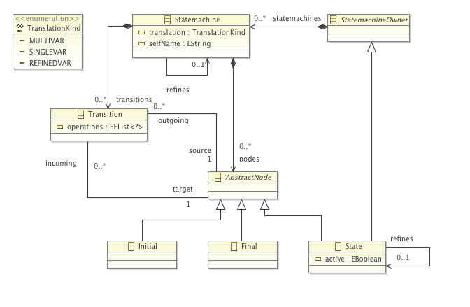

code generated in **ac.soton.eventb.statemachines**

code generated in **ac.soton.eventb.statemachines.edit**

**GMF models**

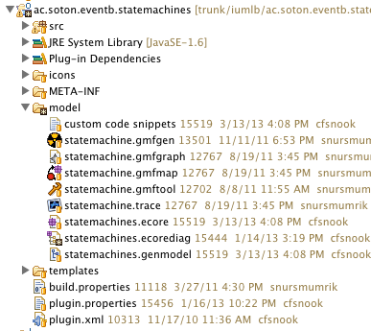

code generated in **ac.soton.eventb.statemachines.diagram**

note use of custom templates

property sheets in **ac.soton.eventb.statemachines.diagram.**sheet.custom

**Navigator**

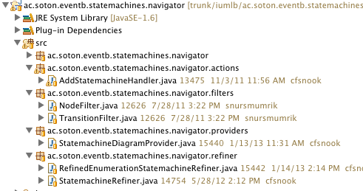

Add handler extPt

Filters (to remove Initial, Final and Transitions from navigator)

SM diagram provider extPt

Statemachine Refiner extPt

(Refined Enumeration)

**Persistence**

Extension only

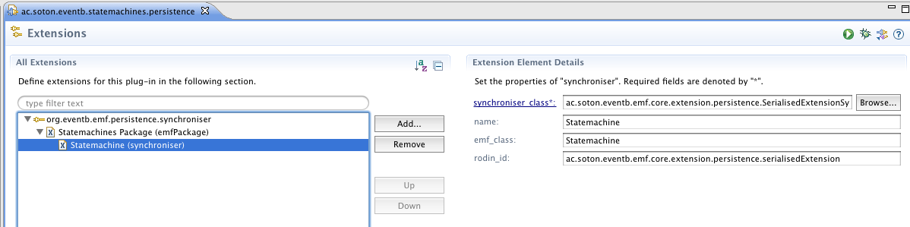

**Transformation**

QVTO

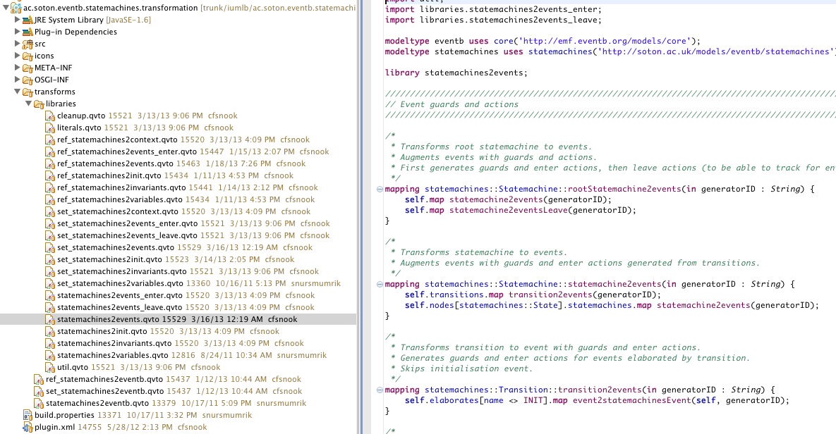

see also class diagram for alternative Java based generator

